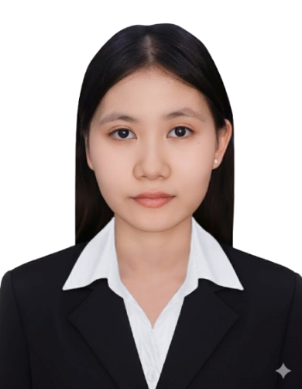
LOEUNG CHHUMSO MARY
Aspiring Software Developer | ICT Student, AUPP
Dananloeung@gmail.com
(+855) 12 809 323
Phnom Penh, Cambodia
Portfolio

PROFILE
Senior Information & Communication Technology student at AUPP with hands-on experience in JavaScript, React, Express.js/Node.js, Python, and AWS cloud computing. Co-founder of SastraAI, an AI-powered bilingual homework tutor for Cambodian students, and co-founder of PoseUp, an AI posture-tracking app. AWS Certified Cloud Practitioner with direct experience building production features on designing user experience and leading go-to-market work. Seeking an internship or graduate program to apply strong programming fundamentals, UX/UI, and applied-AI skills to real-world software projects.
TECHNICAL SKILLS
- Programming & Frameworks: Python, JavaScript, React, Node.js, Express.js
- Cloud & AI: AWS (Certified Cloud Practitioner), applied AI/Machine Learning
- AI-Assisted Development: Codex, OpenCode, Kilo Code (access to models incl. Ling, Nemotron)
- Design & Productivity: Figma, Framer, Microsoft Word, Excel
- Other: UX/UI design fundamentals, Git/GitHub, agile teamwork
PROJECTS
SastraAI — Co-founder 2026 – Present
- An AI tutoring platform for math and science students in Cambodia's bilingual and EMI schools, featuring a Socratic-method chat/voice tutor, OCR worksheet scanning, and Khmer/English language support.
- Contributed in building React (web + mobile) frontend
- Led customer discovery through online parent surveys, and designed a B2B2C go-to-market strategy.
- Passed Semi-Final stage at university venture capital and hackathon pitch competitions at Khmer Enterprise
PoseUp — Co-Founder & UX/UI Designer 2025
- AI-powered web app that tracks human body posture and delivers real-time feedback; led UX/UI design.
- Won 1st Place at the National AI Competition (hosted by CADT, MOEY & RCC), earning an educational trip to Singapore.
Platypus — Frontend E-Commerce Website 2024
- Built a responsive storefront using JavaScript and Bootstrap.
React Movie App 2024
- Built a movie search app in React consuming a public movie API.
WORK EXPERIENCE
Intern Application Developer (3 months) 2026
One Fraternity Co., LTD
May–August 2026
- Developed a centralized employee portal using React, TypeScript, Ant Design, and UmiJS.
- Built announcement, audience-targeting, partner-store approval, map, and Excel export features.
- Integrated REST APIs, managed organizational data, and implemented role-based access control.
- Collaborated through Git branches and pull requests to troubleshoot and deliver features.

Part-Time Marketing Strategist 2024
TIN Cafe & Eatery
EDUCATION
Bachelor of Science, Information & Communication Technology 2023 – Present
American University of Phnom Penh (AUPP) — Fully Funded Scholarship
Bachelor of Education in English 2022 – 2026
Institute of Foreign Language (IFL)
Web Development & UX/UI Certificate 2025
IT Strep Academy
Diploma of Academic Writing and Research 2022
Australian Center for Education
RESEARCH EXPERIENCE
Exploring the Impact of Social Media on IFL Students' Mental Health: Causes, Effects, and Coping Mechanisms 2025
Year 1 Students, Department of English, IFL, RUPP
AWARDS & SCHOLARSHIPS
1st Place, National AI Competition — Educational Trip to Singapore 2025
Hosted by CADT, MOEY & RCC
Web Development & UX/UI Course Scholarship 2025
Funded by Sisters of Code
AWS Certified Cloud Practitioner 2024
Funded by USAID
Fully Funded Scholarship, AUPP 2023 – Present
1st-Year Academic Excellence, 3rd Place (GPA 3.8), IFL 2022
IELTS Band 7.0 (Speaking 6.5, Listening 8.5, Reading 7.5, Writing 6.0) 2022
Grade A, National Entrance Exam, MOEY 2022
CO-CURRICULAR ACTIVITIES
IFL Teaching Practicum — taught Year 1 students, Introduction to Southeast Asia 2026
Sisters of Code Employment Program 2025
Spark Meet Women Bootcamp, TECHO Startup Center 2025
Cloud4Cambodia, USAID 2024
AUPP Journalist Club — published article on food delivery in Cambodia 2023
"Shaping Future Real Estate Leaders," hosted by AIA & AUPP 2023
Future Leader Program, hosted by AMT — event volunteer 2023
REFERENCE
Dr. Tek Ming Ng — Dean & Associate Professor, AUPP
Email: n.ming@aupp.edu.kh

